Design and Implementation Steps:

# Back-end

Back-end service to search location and retrieve the weather for a given location. This should be implemented in a different web API project. Here for time limitation, simply just add this back-end service in current original project.

## Implementation back-end service steps as following:

1. Add two models for data structures: Location.cs and WeatherInfo.cs
2. Add the service MetaWeatherService.cs to call MetaWeather API to search location and retrieve the weather for a given location.

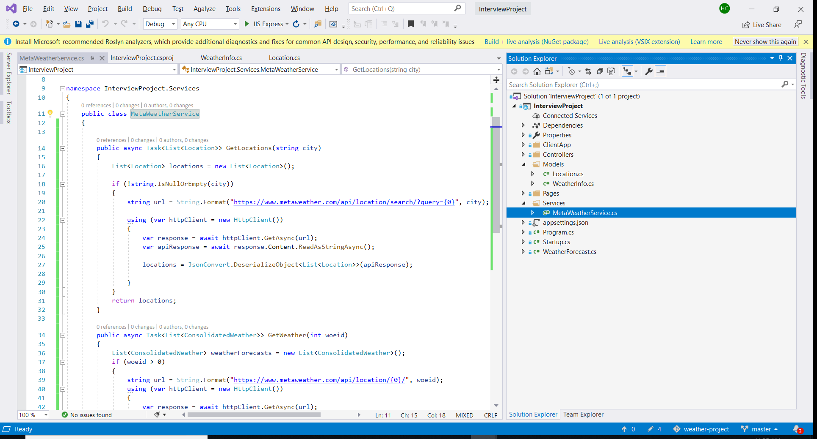

1. Add the unit test project to test the service. All tests passed.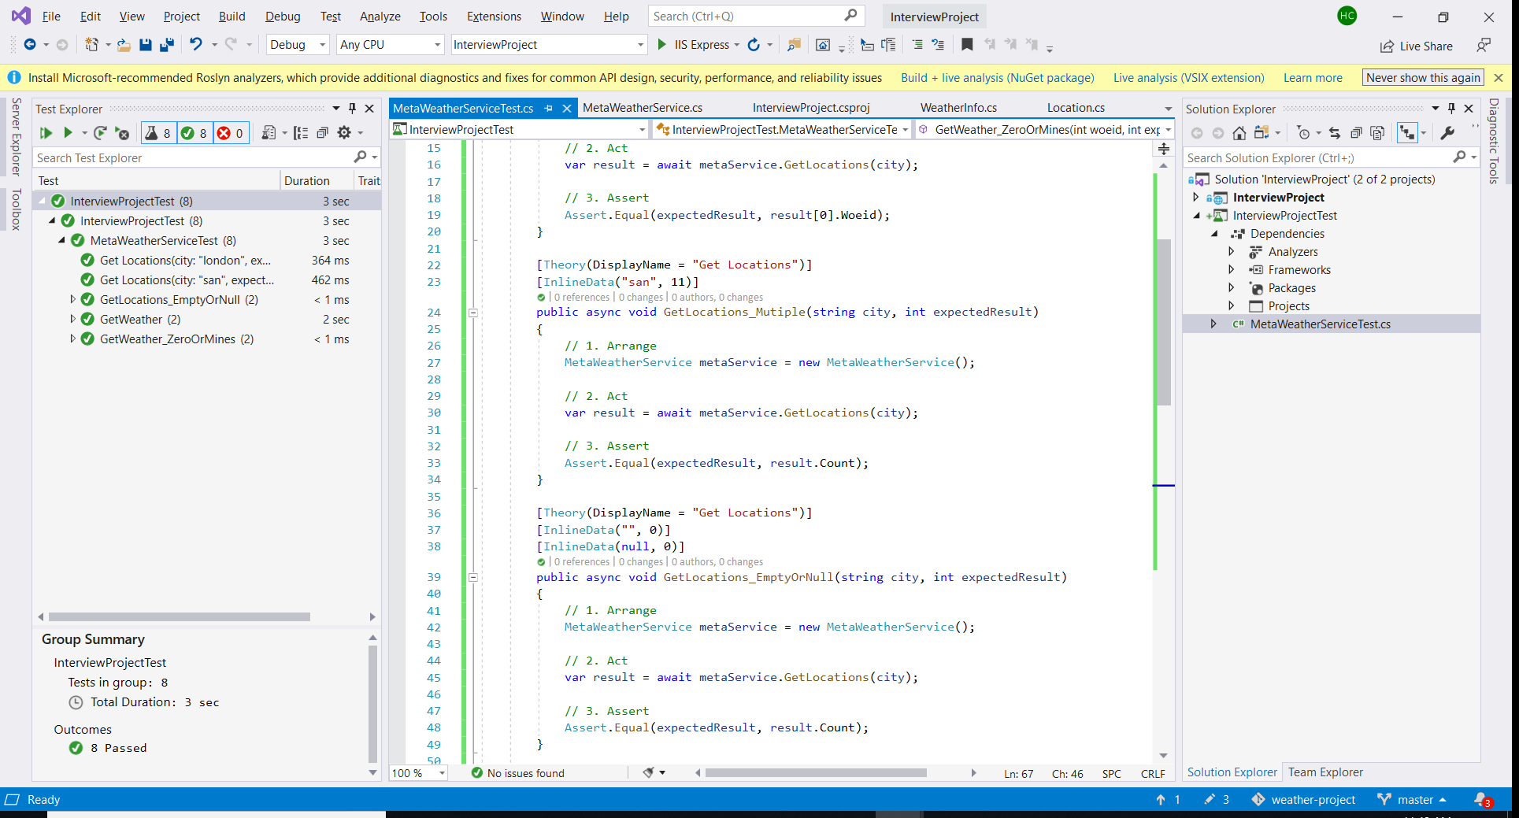

# Front-end

A page to allow the user to search for a location and display a five-day forecast for that location.

## Implementation front-end page steps as following:

1. Add the WeatherLocation controller to get location and weather info from MetaWeatherService.
2. Add the WeatherLocation React Component which includes:

A text box to input the location name,

A “Search” button to generate the locations dropdown list based on the location input value.

A locations dropdown to show the locations for a location selection.

A table to show the 5-days forecast based on the selected location.

1. Modify the NavMenu React Component to add the “Weather By Location” link.

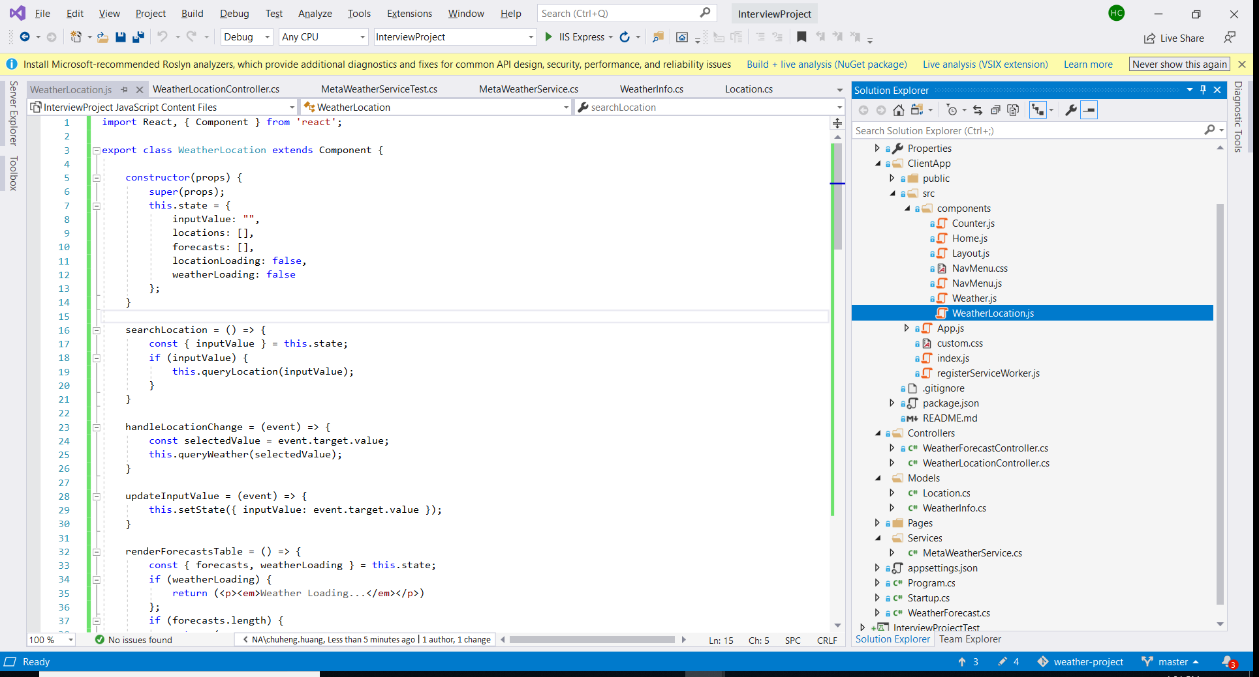

1. Due to time limitation, the followings are not implemented:

UI unit tests

Input validation on UI.

UI data format for good user experience.

# Run Application to test

Test success and results as following page:

